**Communicating With Families: Consolidation Activity Choice Board**

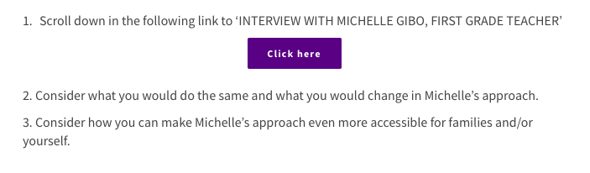

**Answer**

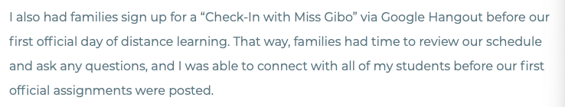

* Providing families with a check-in is extremely important. This allows to open the lines of communication with families and let them know that you are there for them for support. This also allowed them to have a “heads-up” as to what they should expect with distance learning.



* I would have changed this approach, as communication with parents and your students is everything. This is especially important during uncertain and new times. This allows for clear expectations and boundaries. Personally, I would have an exit card daily for students to hand in. On the exit card, I would have multiple faces with different emotions on them. Students would then highlight how they are feeling. Based on what they circle, this would tell me as an educator if I need to do a deeper check-in. Understanding your emotions and being able to express how you are feeling during a time such as this is so critical. Being at home can be harder for many students (tough home life, etc), and it is important to be aware of how your students are feeling.

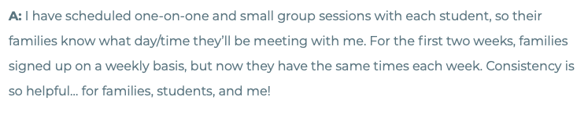

* I think this is a great idea, as it allows for consistency and routine which is very important for students during this unstructured form of learning. I would however, still allow for time-slot choice, as this then allows different students to be working together in their small-group work sessions.

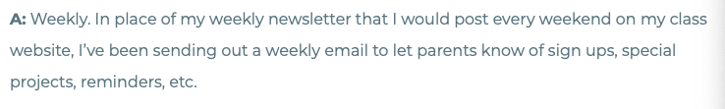

* I agree that weekly check-ins are a great idea. However, I would still continue to use the newsletter idea. This is more “parent-friendly” and less intimidating. I would then also be able to include links parents can click on. I would also create a community space on my website where students/their parents can post the work they have been doing, or parents can send me work they have been doing and I can make pic-collages to display this. Again, this provides a sense of community and a sense of belonging for the students.

**For Example (See Below):**

Here are pieces of documentation that I sent out to parents during my practicum to communicate what we were working on in class. These were sent out via School Messenger. I believe that something like this could be done each week in an online class as an additional communication piece to show the class what their fellow peers had been working on. Especially when they aren’t with whole class.



* Additionally, I would continue to use apps such as (Seesaw and School Messenger) to communicate with parents as this is a quicker and easier way to communicate opposed to email. If there was a parent unable to use such app, I would accommodate.

Accessibility

* You can make it more accessible by adding links and photos
* Provide activities that can be done on and off of the computer (this is especially important for those families with multiple children and only 1 computer). For example, outdoor scavenger hunt, rhyming around the house, card game that practices math skills, etc.
* Not only would I provide the lesson plan, but I would post how the students are going to be assessed. I would also highlight the learning goals that the lesson plan/activity is focussing on.